**Cognizant Digital Nurture 4.0**

***WEEK-2 Module 4 - SL4J Logging***

**Exercise 1: (Mandatory)**

Logging Error Messages and Warning Levels

**Task:**

Write a Java application that demonstrates logging error messages and warning levels using SLF4J.

**Step-by-Step Solution:**

1. **Add SLF4J and Logback dependencies to your `pom.xml` file:**

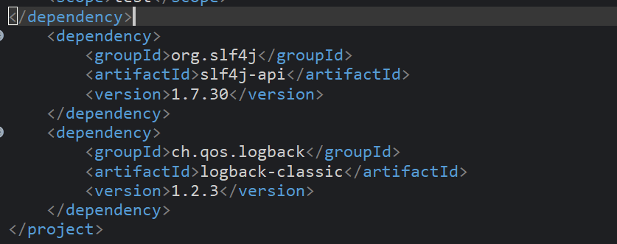

1. **Create a Java class that uses SLF4J for logging:**

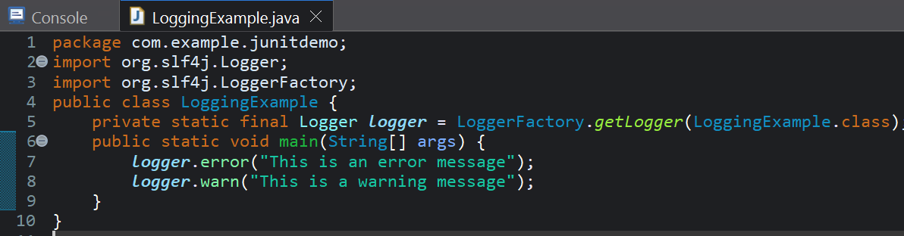

**Output:**



**Exercise 2:** **(Non - Mandatory)**

Parameterized Logging

**Task:**

Write a Java application that demonstrates parameterized logging using SLF4J.

**Step-by-Step Solution:**

1. **Add SLF4J and Logback dependencies to your `pom.xml` file:**



1. **Create a Java class that uses SLF4J for parameterized logging:**

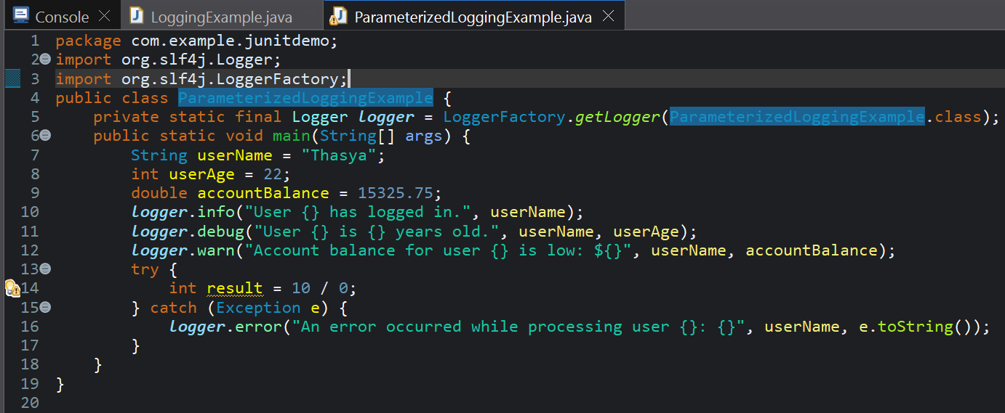

Output:

